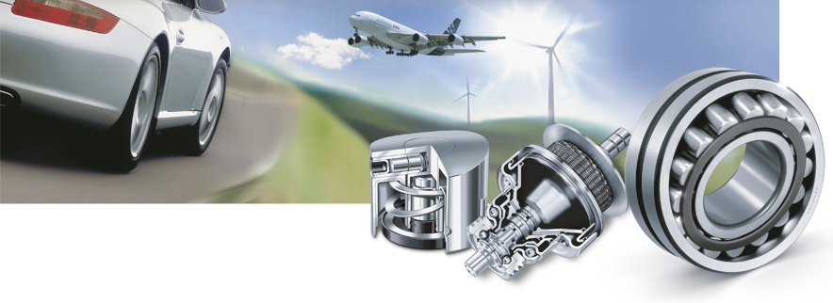
招聘时间：12月5日（周三）14：30
招聘地点：大学生活动中心三楼
（12月6号周四参加大型招聘会）
舍弗勒集团
舍弗勒集团是全球范围内生产滚动轴承和直线运动产品的领导企业，也是汽车制造业中极富声誉的供应商之一。强大的创新能力、全球性的用户近距离服务、高质量的流程管理以及对用户的特殊要求的快速响应能力构成了企业集团成功的坚实基础。通过三个知名品牌 – INA, FAG和LuK, 舍弗勒集团积极活跃在汽车制造业 、工业制造和航空航天领域。集团层次的集中运作方式保证了各部门的和谐发展。用户至上的一贯原则也是企业成功的实质性原因之一。舍弗勒集团把自己视作客户的一个研发合作伙伴并自主开发技术、设备和控制系统以实现快速灵活的生产工艺。
舍弗勒集团中国
自1998年开始在中国投资生产以来，舍弗勒集团逐步拓展生产与营销网络，现已建立了上海安亭研发中心，太仓工厂和宁夏工厂，并在全国设立了11个销售代表处，拥有雇员近4000名，为向中国用户提供长期优质而方便的服务打下了良好的基础。
“优秀的员工创造优秀的企业”是舍弗勒集团一贯的原则。舍弗勒中国区的人事政策十分注重员工晋升通道的建设和激励政策的制定。在公司内部，员工获得广阔且不论资排辈的个人发展空间，拥有令人振奋的职业前景。





Opportunities in the Schaeffler Group China

Required Education
- For engineers: You will have majored in Mechanical Engineering, Automotive Engineering or a similar, related field
- For support functions: You will have majored in Finance, Logistics, Human Resources, Marketing etc.
- For all positions we are looking for excellent recent graduates with a Masters Degree from top Chinese universities or the equivalent qualification from recognised overseas institutions

All applicants should meet following criteria:
- Excellent written and spoken English or German
- Excellent communication skills and computer skills
- Results focused with the ability to solve problems
- Interested in long-term commitment to the Schaeffler Group
- Loyal, trustworthy, hardworking and honest
- Self-confident and team spirited

Schaeffler China offers you:
- Competitive benefits
- Commitment to your development
- The very best technical and non-technical training
- Excellent working environment, with international exposure
- Chance to work with the newest technology in the market
- You will be given a ‘buddy’ from your first day to help you settle into the company and answer any questions you have
Vacancies:
Trainee 管理培训生
Testing Engineer (chassis and transmission) 测试工程师（底盘变速箱）
Sales Engineer (Automotive) 销售工程师（汽车）
Purchasing Engineer 采购工程师
IE Engineer IE工程师
Customer Service Engineer 客户服务工程师
Please send your comprehensive curriculum to the application management or by e-mail to: chinarecruiting@schaeffler.com

